Unit 5 Notes
Naming Chemical Compounds
I. Types of Compounds
There are three main types of compounds when working on Naming Compounds.
________________ Compounds – Contain a metal and a non-metal. They form an ionic bond.

_________________ Compounds – Contain two non-metals. They form a covalent bond.
_________________Compounds – Contain polyatomic ions. The formula will have three or more elements in it.

II. Ionic Compounds
- Name the _______________ element. (This will always be the metal.)
- _______________ the ending on the second element with an “__________” ending. ( This element will be the ___________-____________)
NaCl _______________ ________________
K₂O _______________ _______________

III. Naming Compounds with a Transitional Metal
- There are some atoms that can have more than one possible ________________________.
- A ___________________ numeral is needed to indicate the charge.
- The following elements must have a roman numeral:
Cr-Cu, Au, Hg, Sn, & Pb
- Ex: Cu ⁺¹ is copper (I) Fe ⁺² is iron (II)
Cu ⁺² is copper (II) Fe ⁺³ is iron (III)
CuCl___________ ______________ FeCl₂ _______________ ________________
CuCl₂___________ ______________ FeCl₃ _______________ ________________

IV. Molecular Compounds
- Name the ________________ element
- Replace the ending on the second element with “______________________”
- Use prefixes to indicate the number of atoms in the formula.
- *Exception: A prefix is not required when the first element only has 1 atom.
Examples:
` CO₂ ______________ ________________
N₂O ______________ ________________

Prefixes Molecular Compounds
1 atom = ________
2 atoms = di
3 atoms = tri
4 atoms = ________
5 atoms = penta
6 atoms = hexa
7 atoms = ________
8 atoms = octa
9 atoms = nona
10 atoms = _______

V. Polyatomic Compounds
- Name the __________________ part of the compound. (+ ion)
Element or _________________ ion.
- Name the second part of the compound. (- ion)
_________________ or polyatomic ion.
Examples:
MgSO₄ __________________ __________________
Cu(OH)₂ __________________ __________________
K₃PO₄ __________________ ___________________

VI. Naming Acids without Oxygen
- Acids without Oxygen are named with the prefix “hydro” and end in “ic”
Examples:
HCl _______________________ ___________
HF ________________________ ___________
HBr ________________________ ___________

VII. Naming Acids with Oxygen
Polyatomic ion Name of acid
per_______ate per _______ ic acid
_______ ate ________ic acid
_______ ite ________ ous acid
hypo ______ ite hypo ________ous acid

Examples:
H₂SO₄ ______________________ ____________

HClO ________________________ _______________

-----------------------------------------------------------------------------------------------------------------------------------------------------

Writing Chemical Formulas

I. Ionic Compounds
- Write chemical ____________________ for each part of the compound.
- Write the __________________ (oxidation #) for the element.
- Check if the oxidation numbers add up to zero
1.) If they add up to ______________, the oxidation numbers cancel.
Rewrite with symbols only.
Ex: calcium oxide

2.)If they do not add up to zero, __________ the oxidation numbers to determine the subscript for each element.
Ex: magnesium chloride

Examples:
calcium fluoride ____________________
lead (II) sulfide______________________

copper (I) oxide _____________________

II. Transition Elements
- Same rules as _________________ compounds.
- The charge for the transition metal will come from the ___________________ numeral.
Examples:
iron (III) chloride ______________________

copper (I) oxide______________________

lead (II) nitride_______________________

III. Molecular Compounds
- Use the prefix to determine the ___________________________ of each element in the formula.
- NO PREFIX on the _____________ element indicates a subscript of 1

Examples:
carbon dixoide _____________

sulfur trioxide_________________

carbon tetrachloride________________

IV. Polyatomic Compounds
- The rules for _____________________ ions will be the same as ionic compounds.
- *Polyatomic ions must be placed in ____________________ if the subscript is larger than 1 when criss-crossing.

Examples:
magnesium sulfate________________________

iron (III) phosphate________________________

calcium hydroxide____________________

ammonium carbonate _________________

V. Acids without Oxygen
- Write the __________________ and charge (oxidation #) of each element.
- If the charges do not add up to zero, criss-cross the__________________________ #.

Examples:
hydrosulfuric acid ______________________

hydroiodic acid _____________________

VI. Acids with Oxygen
- Write the symbol and the charge for _____________________ and the polyatomic ion (oxyanion).
- If the charges do not add up to zero, criss-cross the oxidation numbers.
Polyatomic ion Name of acid
per_______ate per _______ ic acid
_______ ate ________ic acid
_______ ite ________ ous acid
hypo ______ ite hypo ________ous acid

Examples:
sulfurous acid________________

nitric acid___________________

Types of Bonds
There are three main types of Chemical bonding.
__________________, ________________________,__________________________

Ionic Bonding occurs when there is a ______________________ of electrons.

Covalent Bonding occurs when atoms _____________________ electrons.

Metallic Bonding consist of the attraction of free ______________ valance electrons for positively charged __________ ions.

__________________ are used to determine what type of ________ is formed when atoms come together in a chemical reaction.

To find the type of __________, find the _________________ in the electro negativities.

If the difference is _______________ than 1.67 an ________ bond is formed.
If the difference is _________ than 1.67 a _________ bond is formed.

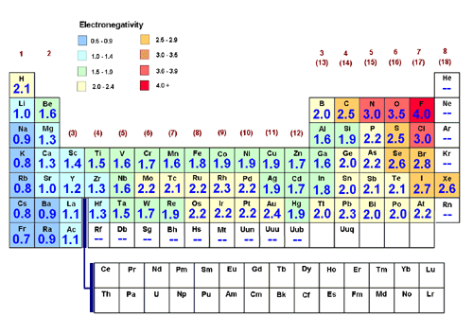

Rules for Ionc Bonding
- All atoms want to obtain eight electrons in the valence energy level. To do so they will give, take, or share electrons.
- The element with the fewest atoms goes in the center.
- The other atoms go around the central atom.
- Show the transfer of the electrons with a positive charge for the atom that lost the electrons and a negative charge for the atoms that gain the electrons.
- Ex: NaCl CaF₂

- Bonds can also be determined by the difference in electronegativities.
NaCl sodium chloride
sodium: (_____) chlorine: (____)
The electronegativity difference is ______- ______ =______
An ionic bond is formed.

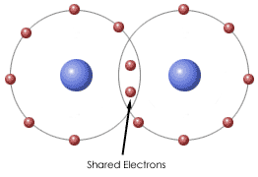
Covalent Bonding:
Elements share e-

Rules for Showing Covalent Bonds
- The element with the fewest atoms goes in the _________________________.
- The other atoms go around the ____________________________ atom.
- A bonding pair can only form where there is an __________ electron.
- Shared pairs or bonding pairs are shown with a ________. One dash equals __________ electrons.
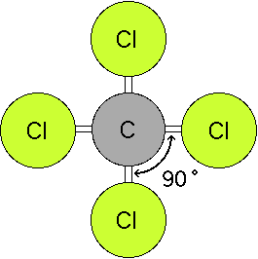

- Example:
- AsI3 arsenic triiodide
arsenic (2.2) iodine (2.7)
The electronegativity difference is 2.7- 2.2 = 0.5
A covalent bond is formed. The atoms share the electrons.

Molecular Geometry

- The shape that a ____________________ bonded substance will take is referred to as its Molecular Geometry.
- The shape is determined by the ___________________ atom, and the number of shared and unshared electron pairs around the atom.
- Electron pairs around the central atom will _________________ _________________ as far as possible to minimize the repulsive forces.
- This gives bond ________________________ depending on the shape.
Total # of electron pairs. | # of shared pairs | # of unshared pairs | Shape | Bond Angle | Draw shape
 |  |  | Linear
Trigonal
Planar
Trigonal
Pyramidal
 |  |  | Bent

