Valence Electrons
- Valence electrons are electrons found on the __________ _________of an atom.
- Electrons available to be lost, gained, or shared in the formation of chemical compounds.
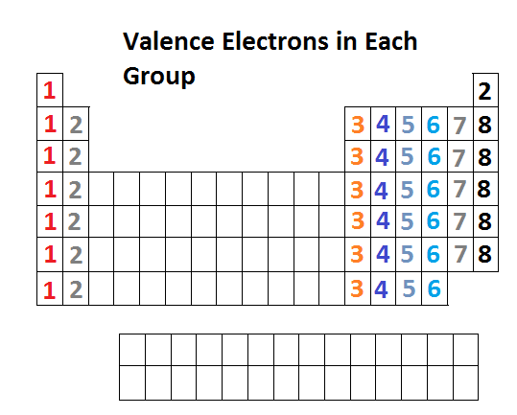
- Found in the ________________ energy level.
- Elements in the _________ group (family) have the same number of valence electrons.
Electron Configuration
- Energy shells are divided into sub-shells as shown in the research of Erwin Schrödinger and Werner Heisenberg
- The sub-shells are labeled as the ___, ___, ___, and ___.
  - The sub-shells each hold a certain number of ____________________________.
  - Each orbital can hold ___ electrons.
- Electron configuration: A shorthand way to keep track of all the _________ in an atom of an element for all the sub-shells that have electrons. The number of electrons in each sub-shell is shown as a _____________________.
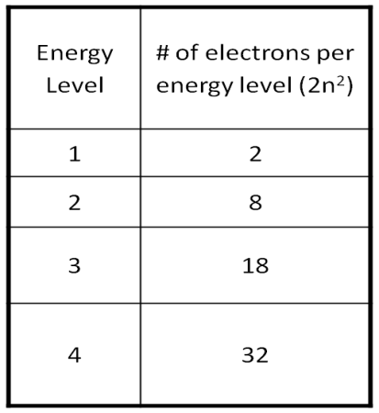
- Electron Shells (n= 1, 2, 3, 4…)
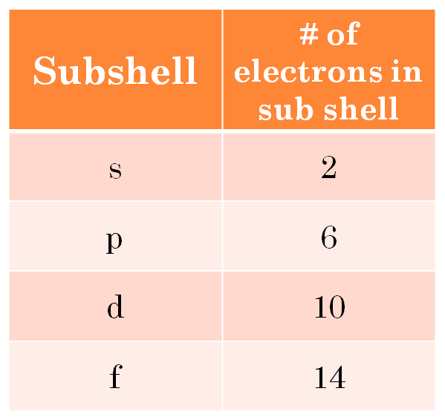
  - The letter n represents the _______ shell or energy level.
- The electron shells in the shell ________ of an atom (except for n =1) are divided into sub-shells.
Electron Sub-Shells (s, p, d, and f)
- Each sub-shell is indicated by its ______ shell number and a letter, either_, __, __, or __.
  - The maximum numbers of _____________ that can occupy s, p, d, and f sub-shells are ___, ___, ___, and ___, respectively.
- Sub-shells can be seen by the separation on the periodic table.
  - Helium is part of the s sub-shell.
- In an electron configuration,
  - the number indicates the shell number;
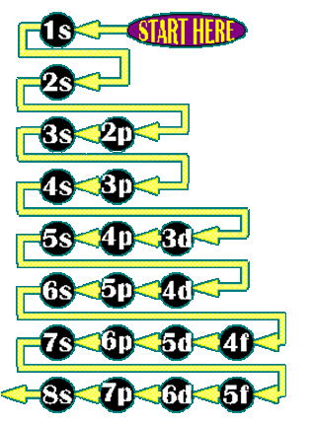
  - the letter indicates the sub-shell within the shell;
  - the _______________ indicates the number of electrons in the sub-shell.
- The superscript numbers sum to the __________ number of electrons for an atom of the element.
  - Example: _________ has __ electrons and its electron configuration is 1s²2s²2p²
  - __ + __ + __ =6 total electron

Electron Configuration and the periodic table
- The periodic table can be used to find the electron configuration for an element.
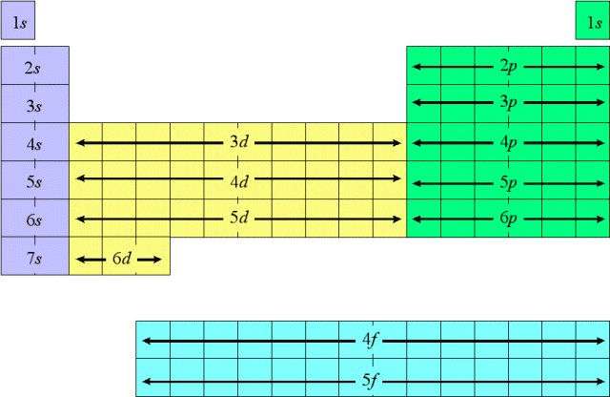
    - First find the ____________ on the periodic table.
    - Then _________ through each element __________ in order by stating the __________ ________, the __________ type, and the __________ of electrons per __________ type until you arrive at the __________.

Guided Practice
Find the electron configuration for selenium, Se.
- Selenium is in the ____ energy shell, in the __ sub-shell, and in the __________ column of the __ sub-shell so its electron configuration should end in _______.
- Just follow the fill order to write the electron configuration.
    - ________________________________________
    - Add up all the superscripts to check if the number equals selenium’s atomic number
      - __ + __ + __ + __ + __ + __ + __ + __ = _____ Se atomic # = 34
Practice
Write the following elements electron configurations.
- Li, Lithium ______________________________________________________________
- K, Potassium _____________________________________________________________
- Kr, Krypton ______________________________________________________________
- Pb, Lead _________________________________________________________________
Noble Gas configuration
- To write a noble gas (_____________) configuration for any element, count backwards from that element until you reach a noble gas.
  - Write that noble gas symbol in ___________.
  - Then, continue forward with next sub-shell(s) - see the attached version of the periodic chart that shows the subshell order with respect to the elements.
- For example, if we wanted to do the shorthand configuration for sodium (Na), you would count back one element to __________ (Ne) and put ____ in brackets.
  - [ ___ ]
- Then, noting that the next correct sub-shell is _____, include the rest of the electrons as we did with the smaller elements.
  - [ ___ ] _______
Practice
- Write the following noble gas configuration for the following elements.
  - Be, Beryllium___________________________________________
  - F, Fluorine_____________________________________________
  - Pt, Platinum___________________________________________

