C, frequency and wavelength
- Wave speed, frequency and wavelength have a mathematical relationship.
  - Using c = λ x ƒ, frequency or _____________________ can be found.
    - Example: what is the wavelength of a wave of light if it has a frequency of 3.2 x 10¹⁴ hertz?

Wave speed, frequency and wavelength practice
- Using v = λ x ƒ or,
  - find the frequency of a 4.00 x 10⁻¹¹ m wavelength of the violet light.

  - find the wavelength of a sound wave with a frequency of 440Hz. (Sound travels at ≈ 330 m/s).

Light Particles and Planck’s constant

Particles of Light
- Scientists in the early 20th century showed that electromagnetic radiation was composed of particles we call _________.
  - __________________ and Albert Einstein.
  - Photons are particles of light energy.
- One wavelength of light has that with that amount of energy.

Planck’s Constant
- Planck ’s constant is a physical constant reflecting the sizes of energy __________ (photons) in quantum mechanics.
  - It is named after Max Planck, one of the founders of quantum theory, who discovered it in 1900.
- The equation is E = h x ƒ where
E = __________, h = Planck’s constant
(6.63 x 10⁻³⁴ J ●s), and f = frequency.

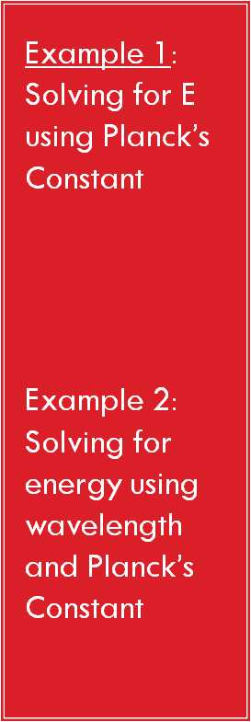
Using Planck’s equation, E = h x ƒ
- What is the energy (Joules) of Violet light with a
frequency = 7.50 x 10¹⁴ s⁻¹?

- Find the energy of light, wavelength is 4.06 x 10⁻¹¹ m.

Energy, wavelength and frequency practice
Answer the following problems. Remember that h = 6.6 x 10⁻³⁴ J● s. Energy = h x ƒ
- What is the energy of a quantum of light with a frequency of 7.39 x 10¹⁴ Hz?

- The energy for a quantum of light is 2.84 x 10⁻¹⁹ J. What is the frequency of this light?

