_________________________ work best when they are accurate and precise
Accuracy | Precision
- Accuracy is a measure of how close a measurement comes to the __________ or ____________ ________________ value of whatever is measured  - __________________  - Poor Accuracy results from ___________or ________________  __________ | - Precision is a measure of how close a ________________ of measurements are to one another  - depends on more than _________ measurement  - _______________________  - Check by _________________ Measurements  - Results from _____________ technique

Accuracy and Precision | Target | Example
The density of water is 1.0g/ml.

You experimental values were:
______ g/ml,
______ g/ml,
______ g/ml,
______ g/ml,
______ g/ml
The density of water is 1.0 g/ml.

Your experimental values were:
______ g/ml,
0.80 g/ml,
______ g/ml,
0.88 g/ml,
______ g/ml

The Atomic mass of Carbon is 12.01 amu’s

Your experimental values were 11.95 amu’s
12.01 amu’s
11.97 amu’s
11.98 amu’s
12.03 amu’s
The Atomic mass of Carbon is 12.01 amu’s

Your experimental values were 11.95 amu’s
11.30 amu’s
10.91 amu’s
11.09 amu’s
12. 53 amu’s

Summary:
The electronegativity of Fluorine is 3.8.  The experimental values were:  2.1  1.6  3.5  2.8  4.2 | 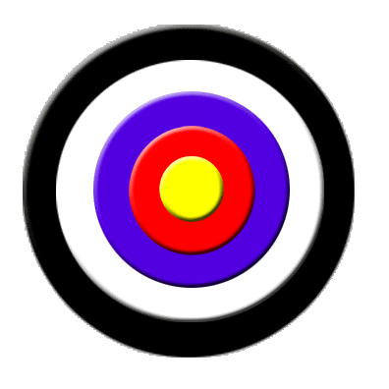
Use this example.

- What kind of example of Accuracy and Precision is this. _______________________________
- Draw the arrows in the Target demonstrating this relationship.

