Chemistry Common Assessment 1 Review

1. Identify the colors associated with the following parts of a hazardous chemical label.
Flammability
Reactivity
Health
Special Concerns

2. How many significant figures do the following numbers have?
12.2000
6.76
0.0045

3. Write the following numbers in correct scientific notation.
4566
.02006
.00345100

4. Using dimensional analysis, convert 2866 seconds to hours.

5. A student using an electronic balance recorded the mass of a wooden block 3 times. Her data set was 5.54 grams, 5.55 grams, and 5.54 grams. The actual mass of the wooden block was 5.22 grams. Is this data accurate, precise, or both?

6. An unknown silvery powder has a constant melting point and does not chemically or physically separate into other substances. How do we classify the unknown substance?

7. What are some chemical properties of water?

8. What are some extensive properties of matter? What are some intensive properties of matter? Be able to identify examples of each.

9. What do we call a solid which forms in a solution during a chemical reaction?
10. Which state of matter has:
A definite volume and an indefinite shape?
An indefinite volume and an indefinite shape?
A definite volume and a definite shape?

11. Using the table below, determine the average atomic mass of the element Iodine.
Isotopes | Mass | % Abundance
Iodine-127 | 127 | 80
Iodine-126 | 126 | 17
Iodine-128 | 128 | 3

12. What are some examples of a pure substance?

13. List some examples of a physical change.

14. Draw the Lewis diagrams for Sodium and Lithium.

15. Write the electron configurations for Carbon, Nitrogen, and Oxygen.

16. A change of state (freezing, boiling, condensing) is considered what kind of change (chemical or physical)?

17. What is the frequency of a photon having an energy of 3 x 10⁻¹⁵?
18. Identify each of the following as a chemical or physical change.
A. Water being absorbed by the large intestine.
B. Enzymes breaking down proteins into amino acids.
C. Saliva changing starches into sugars.
D. Insulin metabolizing sugars.

19. Calculate the energy of a photon of radiation with a wavelength of 2.3 x 10⁻⁷ m.

20. Draw the Lewis structure for Silicon, Germanium, and Tin.

21. What color of visible light has the shortest wavelength? The longest wavelength?

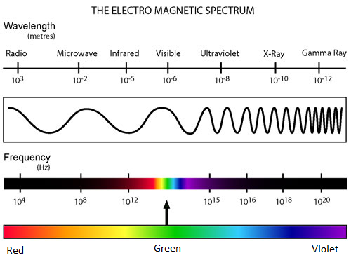

22. Write the electron configurations for Sulfur, Chlorine, and Argon.

23. A solution is also known as a _________________ solution.

24. Using the noble gas configuration, write the electron configuration for the following elements.

A. Nitrogen
B. Selenium
C. Silicon
D. Silver

25. What were the contributions for each of the following scientists?
A. Bohr

B. Dalton

C. Thomson

D. Rutherford

