Chemical & Physical Changes Lab
OBJECTIVE:
Observation of chemical and physical changes
MATERIALS:
Part A:
1 tsp. copper (II) chloride 150 ml beaker
1 stirring rod 8 cm x 8 cm piece of aluminum foil
1 hand lens 1 thermometer
10 ml graduated cylinder 25 ml graduated cylinder
10 ml 3M hydrochloric acid 25 ml distilled water
Part B:
10 ml graduated cylinder 1 test tube
5 ml of 3M sulfuric acid 1 piece of zinc
1 wood splint 1 test tube rack
Part C:
4 ml of 0.20 M silver nitrate 10 ml graduated cylinder
1 dropper of hydrochloric acid 1 test tube
1 test tube rack
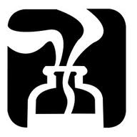
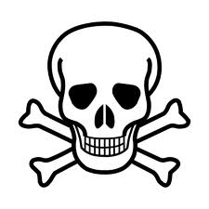
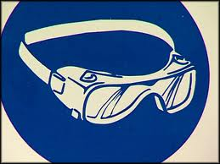
SAFETY:

PROCEDURE:
Part A:
- Get a teaspoon of copper (II) chloride and carry it to your desk on a piece of paper towel.
- Place 25 ml of distilled water in the 150 ml beaker.
- Add the copper (II) chloride without stirring. Record your observations of the crystal and water in data table 1.
- Stir the solution with the stirring rod until the solid dissolves completely. Record your observations in data table 1.
- Record the temperature of the solution in data table 1.
- Obtain 10 ml of 3M hydrochloric acid in the 10 ml graduated cylinder.
- Carefully pour the acid into the beaker. Record your observations in data table 1.
- Record the temperature of the solution in data table 1.
- Obtain a piece of aluminum foil and loosely crumple into a ball. Record your observations in data table 1. CAUTION: DO NOT LOOK DIRECTLY DOWN INTO THE BEAKER.
- Using a stirring rod, carefully stir the mixture. Record the highest temperature as the final temperature in data table 1.
- Discard the contents of the beaker in the waste container on my desk.
Part B:
- Measure 5 ml of sulfuric acid in a 10 ml graduated cylinder. Pour the acid into the test tube. Record the physical characteristics of the acid into data table 2. Place the test tube in the test tube rack.
- Obtain 1 piece of zinc. Record the physical characteristics in data table 2.
- Add zinc to the acid. Let the solution react for 2 minutes. Record your observations in data table 2.
- Hold the test tube in your hand and cover the open end with your thumb. You will begin to feel a buildup of pressure.
- After a few seconds remove your thumb and quickly bring the burning end of the wooden splint into the mouth of the test tube. Record your observations in data table 2.
- Discard the contents of the test tube in the waste container on my desk.
Part C:
- Measure 4 ml of silver nitrate in a 10 ml graduated cylinder. Pour the solution into a test tube. Record the physical characteristics in data table 3.
- Obtain a dropper bottle of 3M hydrochloric acid. Record the physical characteristics of the acid in data table 3.
- Add 3 drops of the hydrochloric to the test tube. Record your observations in data table 3.
- Discard the contents of the test tube in the waste container on my desk.
CLEAN ALL GLASSWARE AND EQUIPMENT. WASH OFF LAB TABLES. WASH YOUR HANDS BEFORE LEAVING THE LAB.
DATA:
DATA TABLE 1
 | OBSERVATIONS | TEMPERATURE | PHYSICAL OR CHEMICAL CHANGE? WHY?
copper (II) chloride & water |  | X
after stirring
copper solution & hydrochloric acid
Solution & aluminum foil |  | X
Solution & foil after stirring

DATA TABLE 2
 | OBSERVATIONS | PHYSICAL OR CHEMICAL CHANGE? WHY?
sulfuric acid |  | X
Zinc |  | X
sulfuric acid & zinc
Wooden splint

DATA TABLE 3
 | OBSERVATIONS | PHYSICAL OR CHEMICAL CHANGE? WHY?
silver nitrate |  | X
hydrochloric acid |  | X
silver nitrate & hydrochloric acid

RELATED QUESTIONS:
- What effect does stirring have on a reaction? Why?
- What data from the first table are quantitative?
- What is the difference between a physical change and a chemical change?
- What things indicate a chemical change has occurred?
- State whether the following types of matter are a heterogeneous mixture (M), a solution (S), a compound (C), or an element (E).
  - lead e. ice h. sugar water
  - air f. salad i. mercury
  - bronze g. car j. water
  - sodium chloride

