Periodicity: Periodic Table
- Periodic Law
  - The __________________________________________ properties of the elements are periodic functions of their atomic numbers; properties of the elements occurred at repeated intervals called periods.
  - This defines the property of periodicity

- Periodic Trends
  - properties that show ____________________________ when examined across the periods or vertically down the groups
  - while there are many periodic trends, we will focus on
    - _________________________ (the plural of radius)
    - _________________________
    - _________________________
    - _________________________ (the plural of radius)

- 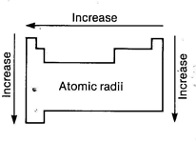Atomic Radii
  - ______________________ the distance between the nuclei of identical atoms that are bonded together.
  - Distance between nuclei ____________________across periods because the higher nuclear charge (positive) pulls the electrons closer to the nucleus
  - 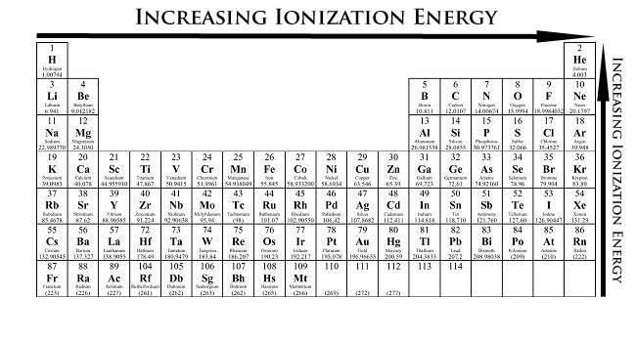increases down groups because energy levels are being added outside the nucleus

- Ionization __________________
  - The energy required to remove one electron from a neutral atom of an element.
  - _______________ across periods because it takes more energy to overcome the electrons attraction to the increasing nuclear charge
  - __________________ down groups because it is easier to overcome the nuclear charge for the outermost electrons as the number of energy levels increases
- ________________________
  - A measure of the ability of an atom in a compound to _____________________________ from other atoms.
  - 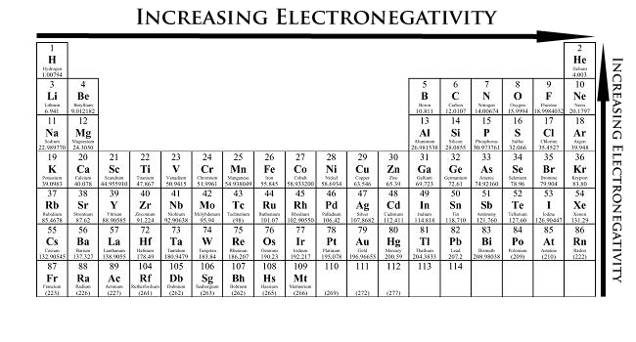________________ across periods as a result of the increasing nuclear charge and ability of the nucleus to attract electrons from a neighboring atom
  - ________________ down groups because the nuclear charge is less able to attract electrons from another atom as additional energy levels are added

- Atomic ____________________
  - The radius of an atom forming _____________________ or an ion. The radius of each atom in an ionic bond will be different than that in a covalent bond.
  - 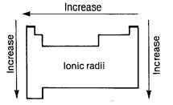The reason for the variability in radius is due to the fact that the atoms in an ionic bond are of greatly different size. One of the atoms is a _______________, which is smaller in size, and the other atom is an anion which is a lot larger in size.
  - ______________across the period until formation of the negative ions then there is a sudden increase followed by a steady decrease to the end
  - The sudden __________________________ on formation of negative ions is due to the new (larger) outer shell

