Geography is everything!
Periodic Families
- 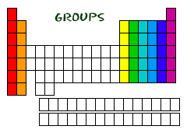Groups and Periods
  - Groups
    - _______________________ containing elements with similar properties. Groups are also called families due to their similar __________________and ________________________ properties.
    - 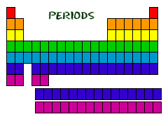For this course, the groups are numbered 1-18 with Group 1 being on the far left and Group 18 being on the far right of the periodic table.
  - Periods
    - ______________________________ in order of atomic number; each period represents a finite grouping of elements
    - Currently, there are 7 periods
- 3 Types of Elements
  - ___________________
    - good conductors of heat and electricity
    - 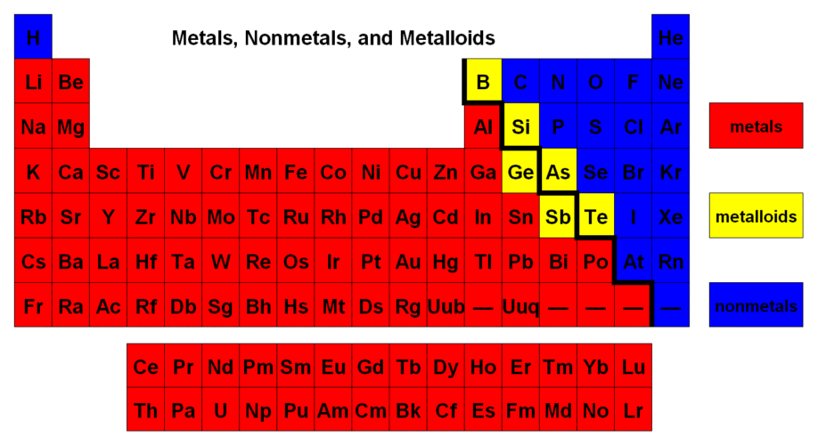Malleability → hammered or rolled, bendable
    - Ductile → can be pulled into wire
    - Luster → shiny when polished
  - ____________________
    - Brittle → not malleable or ductile
    - Poor conductor of heat and electricity
  - ____________________
    - brittle solids
    - have some properties of metals and nonmetals
    - semiconductors of electricity

- Families
  - 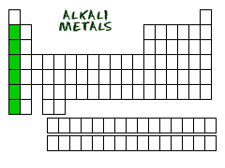Group _____: Alkali Metals
    - Elements contained: Li, Na, K, Rb, Cs, Fr
    - have 1 electron in the outside shell
    - extremely ____________________, reacts with water, air, and
    - nonmetals and silvery
    - soft, can be cut with a knife
    - they are not found as pure elements in nature

  - 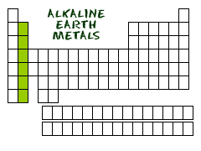Group 2: ___________________ Earth Metals
    - Elements include: Be, Mg, Ca, Sr, Ba, Ra
    - Second most reactive group of metals
    - Have ___________________ in the outside shell
    - Harder, denser and stronger than alkalis
    - They are not found as pure elements in nature

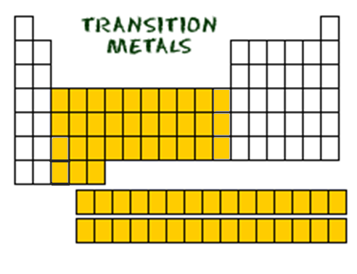
  - Group _____________: Transition Metals
    - many of the most commonly recognized metals are in these groups
    - ______________conductors of electricity
    - tend to have a high luster
    - typically less reactive than alkali and alkaline earth elements
    - many are found in pure form
    - 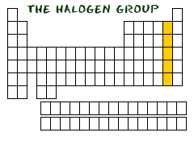some are the most dense of all elements

  - Group 17: _________________
    - Contain elements: F, Cl, Br, I, At
    - __________________ in outer shell
    - most reactive nonmetals
    - react with most metals to form compounds called salts
    - fluorine and chlorine are gases

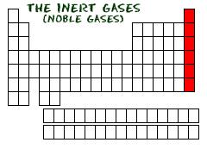
  - Group _______: Noble Gases
    - Includes elements: He, Ne, Ar, Kr, Xe, Rn
    - _______________ gases that do not react with anything, found as individual atoms
    - Have 8 electrons in the outer shell (stable configuration)
    - Neon, Argon, Krypton, and Xenon are all used for different types of lighting
    - Radon is radioactive
    - A few noble gas compounds have been formed under _____________________________

Element placement in the periodic table is VITAL and is not by accident! Elements belonging to certain families have similar physical and chemical properties! So in periodic table, you really are who you group with!

