The History of the Modern Periodic Table
Formation of the Periodic Table of Elements
During the nineteenth century, chemists began to categorize the elements according to similarities in their physical and chemical properties. The end result of these studies was our modern periodic table.
- John Newlands
  - 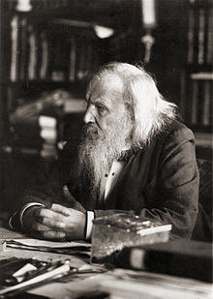In 1863, he suggested that elements be arranged in “___________” because he noticed (after arranging the elements in order of increasing atomic mass) that certain properties repeated every 8th element.
- Dmitri Mendeleyev:
- “_______________________”
  - Dmitri Mendeleyev (1834-1907), a Russian chemist, created the first published periodic table in ____________.
  - Mendeleyev noticed patterns in the properties of the elements [63 then-known], and ingeniously was the first to organize the elements not just according to their __________________________ properties…but also by increasing ______________________.
- Background on Mendeleyev
  - Mendeleyev was born in Siberia in 1834, the seventeenth child in a very large family.
  - He moved to Saint Petersburg to study ______________ , but he was not accepted and instead became a chemistry professor.
  - It is said that he went to sleep one night and dreamt of a table where the elements were.
- Mendeleyev Arrangement
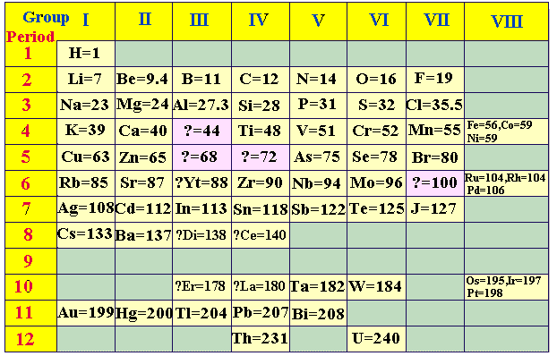
  - Unlike the scientist before, Mendeleyev pieced the table together based on several specific elemental properties:
    - _______________: Mendeleyev placed elements with increasing atomic mass across a row from left to right and down a column
    - _______________ : Property that describes how easily an element will combine with other substances to form a new compound
    - _______________: Mendeleyev paid attention to which elements combined with which, and the ratios in which their atoms combine

- Predictive Value
  - Mendeleyev was so exact with his organization of the elements that his table demonstrated _______________________.
  - Using his periodic table, Mendeleyev was able to corrected the atomic masses of Be, In, and U and accurately predict the discovery of Sc, Ga, and Ge.
  - 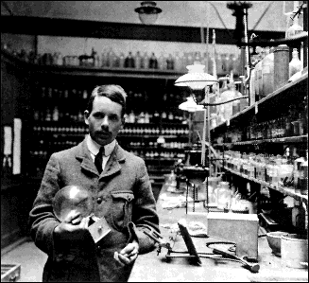After the discovery of the unknown elements between 1874 and 1885, and the fact that Mendeleev’s predictions for _____, ______, and ______ were amazingly close to the actual values, his table was generally accepted.

- Henry Moseley
- Modified in 1913 by Henry Moseley (1887-1915) into the modern Periodic Table
  - Arranged in rows (______________) of increasing Atomic Number – that is, increasing number of protons
  - Arranged in columns (_______________) by repetition of physical and chemical properties
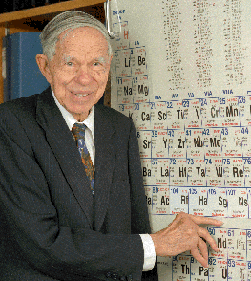
- Glenn Seaborg
  - In 1944, he identified the __________ and _________ series while working on the Manhattan Project during World War II.
  - Seaborg is credited with the discovery of 8 new elements.

- Modern Periodic Table Now
  - Through the laborious work of these and many more scientists the periodic table was created and a scientific masterpiece was born!

